
Report

Team ID | MCA
Project Name | Heart Disease Risk and Patient Health Analysis
Maximum Marks | 5 Marks

Report1

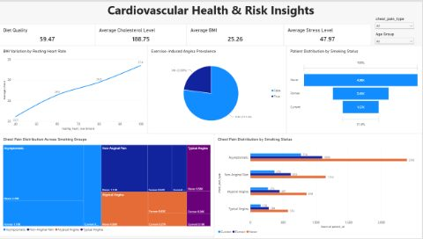
- Cardiovascular Health & Risk Insights Report
1. Executive Summary
The dashboard presents an overall cardiovascular health profile based on cholesterol, BMI, stress, diet quality, resting heart rate, smoking status, chest-pain type, and exercise-induced angina.
Key observations include:
  - Average cholesterol: 188.75
  - Average BMI: 25.26
  - Average stress score: 47.97
  - Average diet-quality score: 59.47
  - Exercise-induced angina: 22.88% of patients
  - No exercise-induced angina: 77.12%
  - Largest smoking group: Never smokers, at approximately 4.98K patients
The dashboard also shows a positive relationship between resting heart rate and average BMI, with average BMI increasing from 22.5 at a resting heart rate of 40 bpm to 27.4 at 100 bpm.

2. Overall Health Profile
Indicator | Average / Value | Interpretation
Diet Quality | 59.47 | Indicates the average diet-quality score in the dataset
Cholesterol | 188.75 | Average cholesterol measurement
BMI | 25.26 | Average BMI is around the overweight threshold
Stress Level | 47.97 | Moderate average stress score, assuming the dashboard's scale is higher-is-more-stress
These figures provide a useful baseline for understanding the population but should not be interpreted as clinical diagnoses without knowing the measurement definitions, units, and patient characteristics.

3. Exercise-Induced Angina
The pie chart shows:
  - 31K patients (77.12%) — no exercise-induced angina
  - 9M patients (22.88%) — exercise-induced angina
Approximately one in five patients therefore falls into the exercise-induced-angina category in this dataset.
This is an important variable for cardiovascular-risk analysis because exercise-related chest symptoms can warrant clinical evaluation. The dashboard association should be treated as a population-level pattern, rather than evidence that an individual patient has cardiovascular disease.

4 BMI. and Resting Heart Rate
The dashboard demonstrates a clear upward pattern:
Resting Heart Rate | Average BMI
40 bpm | 22.5
60 bpm | 24.6
80 bpm | 25.8
100 bpm | 27.4
Average BMI rises by approximately 4.9 BMI points between the lowest and highest displayed resting-heart-rate groups.
This indicates an association between the two variables in the displayed data. However, the chart alone does not establish that a higher resting heart rate causes higher BMI, or vice versa. Other demographic, behavioral, or clinical factors may contribute.

5. Smoking Status
Patient distribution is:
  - Never smokers: 4.98K
  - Former smokers: 2.45K
  - Current smokers: 1.57K
Never smokers constitute the largest group, while current smokers constitute the smallest.
The chest-pain breakdown also shows that Never smokers have the largest absolute number of patients in every displayed chest-pain category. This should be interpreted alongside the different sizes of the smoking groups; absolute counts alone do not measure the prevalence or risk of a chest-pain category within each smoking group.

6. Chest-Pain Distribution
The dashboard identifies four chest-pain categories:
  - Asymptomatic
  - Non-Anginal Pain
  - Atypical Angina
  - Typical Angina
Asymptomatic cases have the highest overall counts, followed by non-anginal pain, atypical angina, and typical angina.
The displayed counts by smoking status further show that never smokers have the highest absolute patient counts for each category, followed by former and current smokers.
For meaningful comparisons between smoking groups, however, percentages within each smoking group would be more informative than raw patient counts.

7. Key Risk Patterns for Further Analysis
The dashboard highlights several relationships worth investigating:
A. Resting heart rate and BMI
The increasing BMI trend across resting-heart-rate levels suggests that these variables should be examined together in further analysis.
B. Exercise-induced angina
With 22.88% of the displayed population categorized as having exercise-induced angina, this variable represents an important subgroup for additional clinical and demographic analysis.
C. Smoking and chest pain
Smoking status and chest-pain type show different distributions, but the current dashboard primarily presents counts. Calculating chest-pain prevalence within each smoking group would provide a more appropriate comparison.
D. Multiple risk factors
BMI, cholesterol, stress, diet quality, resting heart rate, smoking status, and exercise-induced angina could be analyzed jointly to determine whether combinations of factors are associated with different cardiovascular outcomes.

8. Recommended Analytical Extensions
For a more comprehensive cardiovascular-risk assessment, the dashboard could be enhanced with:
  - Chest-pain percentage by smoking status
  - Exercise-induced angina by smoking status
  - Cholesterol distribution by age group
  - BMI distribution by age and sex
  - Resting heart rate vs. cholesterol
  - Stress level vs. BMI
  - Diet quality vs. cholesterol
  - Multivariable analysis to determine which factors remain associated after accounting for other variables
  - Confidence intervals and statistical significance where appropriate

Report2
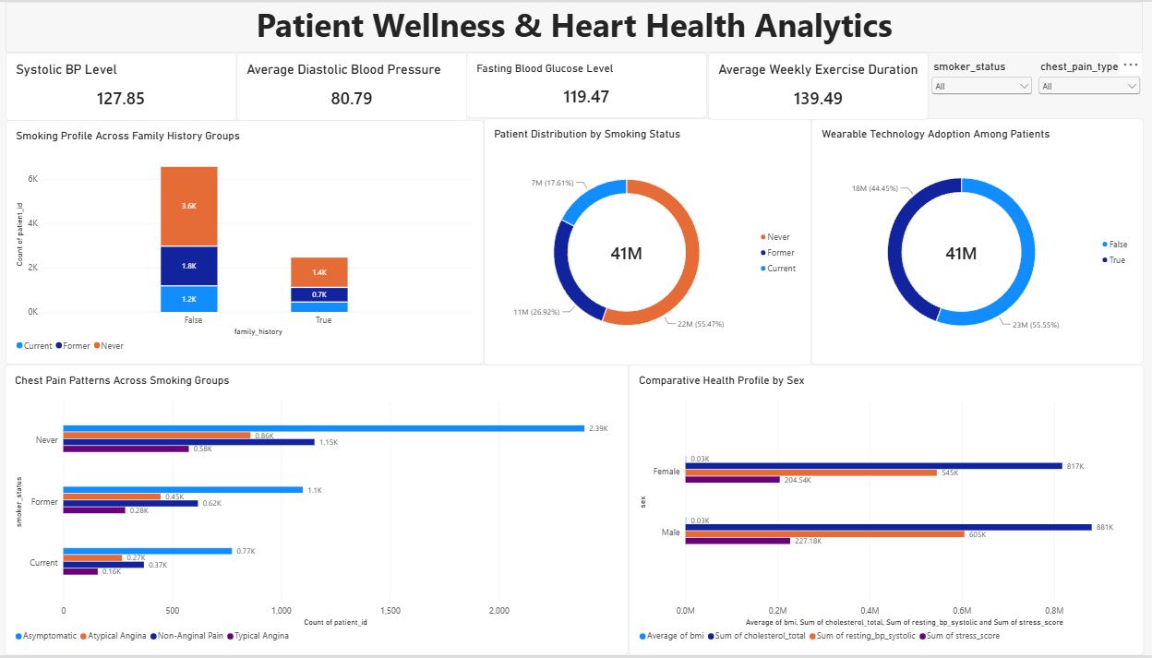

Patient Wellness & Heart Health Analytics Report
1. Executive Summary
The Patient Wellness & Heart Health Analytics dashboard provides an overview of cardiovascular health indicators, lifestyle behaviors, smoking status, family history, chest-pain patterns, wearable adoption, and demographic health measures.
Overall, the dashboard indicates that patients have an average systolic blood pressure of 127.85 mmHg, diastolic blood pressure of 80.79 mmHg, and fasting blood glucose of 119.47. Patients report approximately 139.49 minutes of exercise per week, providing a useful view of physical activity within the population.
Smoking status is concentrated among never smokers, while patients without a family history constitute the larger family-history group. Chest-pain analysis shows that asymptomatic presentations are the most common across smoking groups. The gender comparison also demonstrates differences across cholesterol, resting blood pressure, and stress-related measures.

2. Key Health Indicators
Indicator | Average / Observation
Systolic Blood Pressure | 127.85 mmHg
Diastolic Blood Pressure | 80.79 mmHg
Fasting Blood Glucose | 119.47
Weekly Exercise | 139.49 minutes
These measures provide a high-level baseline of cardiovascular and metabolic characteristics in the displayed patient population. They should be interpreted as population averages rather than individual clinical assessments.

3. Family History & Smoking Profile
Family History
The dashboard shows approximately:
- 6.5K patients without a family history
- 2.5K patients with a family history
Thus, the displayed population is substantially larger in the group without a reported family history.
Smoking Status
The smoking distribution is approximately:
- Never smokers: 4.98K
- Former smokers: 2.45K
- Current smokers: 1.57K
Never smokers therefore constitute the largest smoking-status group in the displayed dataset, followed by former and current smokers.

4. Chest-Pain Analysis
Chest-pain patterns were examined across never, former, and current smokers.
The major observation is that asymptomatic cases are the most frequent chest-pain category across all three smoking groups. Typical Angina appears as the smallest category across the groups.
The larger number of chest-pain observations among never smokers should be interpreted alongside the fact that never smokers are also the largest smoking-status population. Raw counts therefore do not necessarily indicate that smoking status itself causes a particular chest-pain pattern.
For meaningful comparison, rates or percentages within each smoking group would be useful in addition to absolute patient counts.

5. Wearable Technology Adoption
The dashboard reports approximately:
- 55.55% associated with wearable ownership
- 44.45% without wearable ownership
This suggests that wearable technology is represented among more than half of the displayed patient population/measure.
Wearable adoption could potentially support future analysis of relationships between physical activity, cardiovascular indicators, and patient wellness behaviors. However, the dashboard alone does not establish that wearable ownership improves health outcomes.

6. Gender-Based Health Profile
The comparative health profile shows differences between male and female patients across several measures, including:
- Cholesterol
- Resting blood pressure
- BMI
- Stress-related measures
- Other cardiovascular indicators
The visualization indicates that these measures vary by sex in the displayed dataset. Further statistical analysis would be required to determine whether the observed differences are statistically significant and whether they remain after accounting for factors such as age, smoking status, exercise, and other patient characteristics.

7. Major Findings
Finding 1 — Cardiovascular indicators provide a useful population baseline
The average BP and glucose values establish a broad picture of cardiovascular and metabolic health in the dataset.
Finding 2 — Physical activity is measurable across the population
The average weekly exercise duration of 139.49 minutes indicates a meaningful level of reported physical activity.
Finding 3 — Never smokers form the largest smoking-status group
Approximately 4.98K patients are classified as never smokers, compared with approximately 2.45K former smokers and 1.57K current smokers.
Finding 4 — Family-history groups differ considerably in size
The population without a reported family history is considerably larger than the group with a family history.
Finding 5 — Asymptomatic cases dominate chest-pain categories
Asymptomatic presentation is the most frequently observed chest-pain category across smoking groups.
Finding 6 — Wearable adoption is substantial
Approximately 55.55% of the displayed measure is associated with wearable ownership, creating an opportunity for further digital-health analysis.
Finding 7 — Health measures vary across sex groups
The dashboard demonstrates differences in cholesterol, blood pressure, BMI, and stress-related measures between male and female patients.

8. Recommended Analytical Next Steps
To turn this dashboard into a more actionable clinical analytics report, the following analyses would add value:
- Age-group analysis — compare BP, glucose, cholesterol, and stress measures across age bands.
- Smoking-adjusted analysis — calculate chest-pain percentages within each smoking group rather than relying only on patient counts.
- Risk-factor relationships — examine relationships among exercise, BMI, BP, glucose, cholesterol, and stress.
- Family-history analysis — compare cardiovascular indicators between patients with and without a family history.
- Wearable analysis — compare exercise duration and health indicators between wearable and non-wearable users.
- Trend analysis — if longitudinal data are available, track changes in BP, glucose, exercise, and other indicators over time.
- Statistical testing — assess whether observed differences between demographic or behavioral groups are statistically significant.

